# **Module 1**

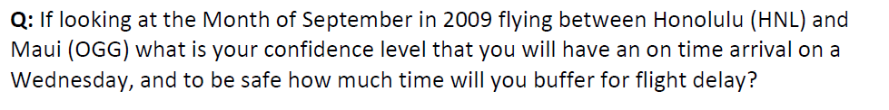

Ans) On time arrival = 59% and Average delay is approx. 13 mins if flight is from OGG and 6 mins if flight is from HNL.

